**PROBLEM DESCRIPTION:**

**Problem 1:** You are asked to design a database for an online learning website. Using this website, a student may take as many online courses as he/she wants. An online course may be taken by any number of students. Each student must rate the course that he/she takes using a like-scale from 1 to 5. Thus, the *popularity* of a course is calculated based on the average scores rated by the students.

**BUSINESS RULES:**

1. Student may take as many courses he/she wants
2. An online course can be taken by any number of students.
3. Each student must rate the course.
4. Each course must be rated.
5. Each Record must be unique

**MS-VISIO**



**MS-ACCESS:**

**Relationship:**

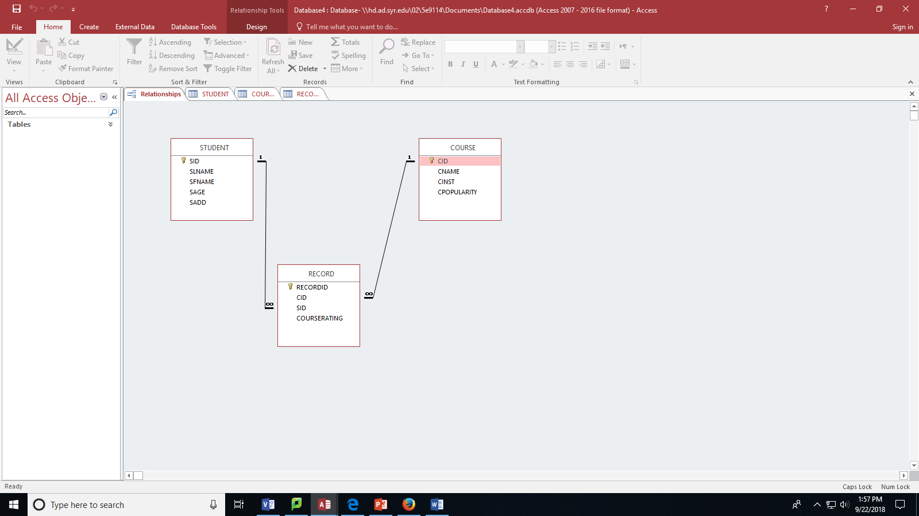

**Tables:**

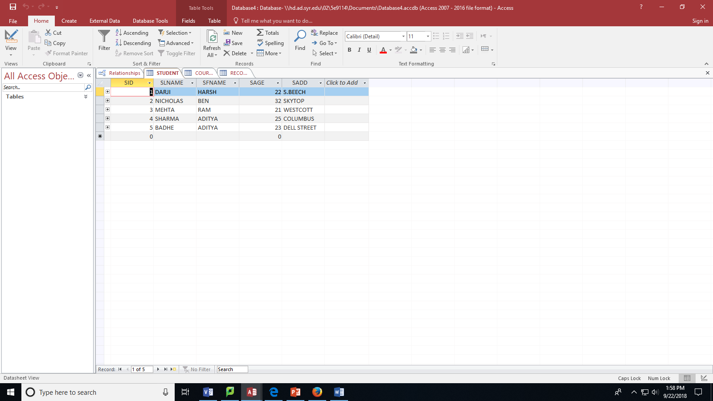

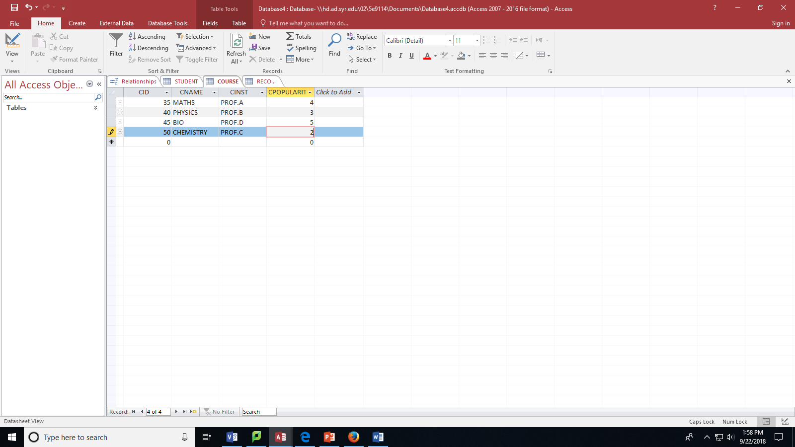

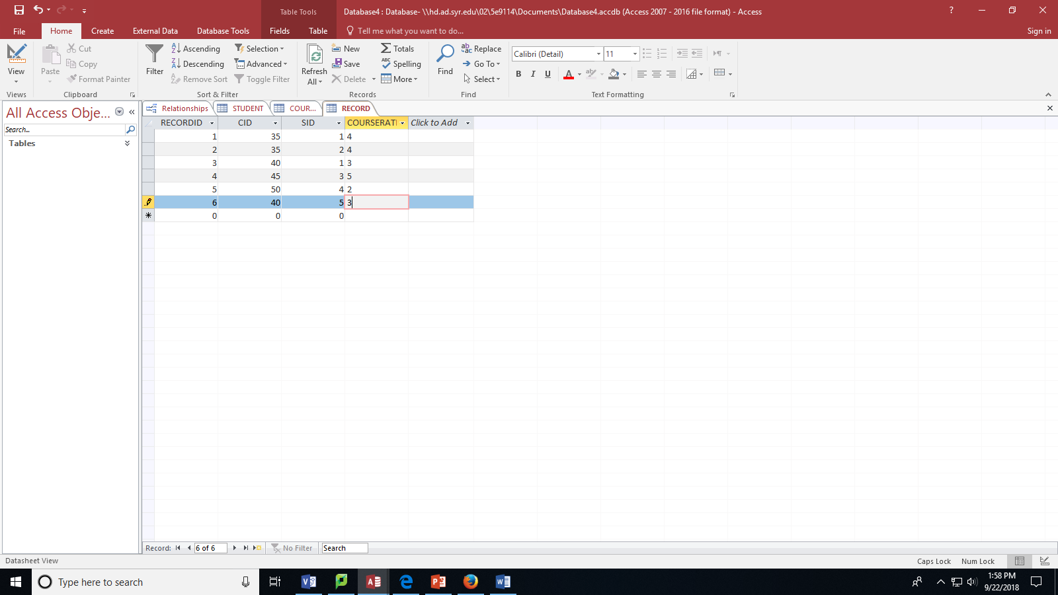

**Problem 2:** Below is an example of a ternary relationship: Doctor prescribes medicines for patients. Please create a different ternary relationship on your own, model it, and create the database tables.

Business Rules:

1. Each vendor can supply many parts to any number of warehouses but need not supply any parts.
2. Each part can be supplied by any number of vendors to more than one warehouse, but each part must be supplied by at least one vendor to warehouse
3. Each warehouse can be supplied with any number of parts from more than one vendor, but each warehouse must be supplied with at least one part.

**MS-VISIO:**



**MS-ACESS:**

**Relationship:**

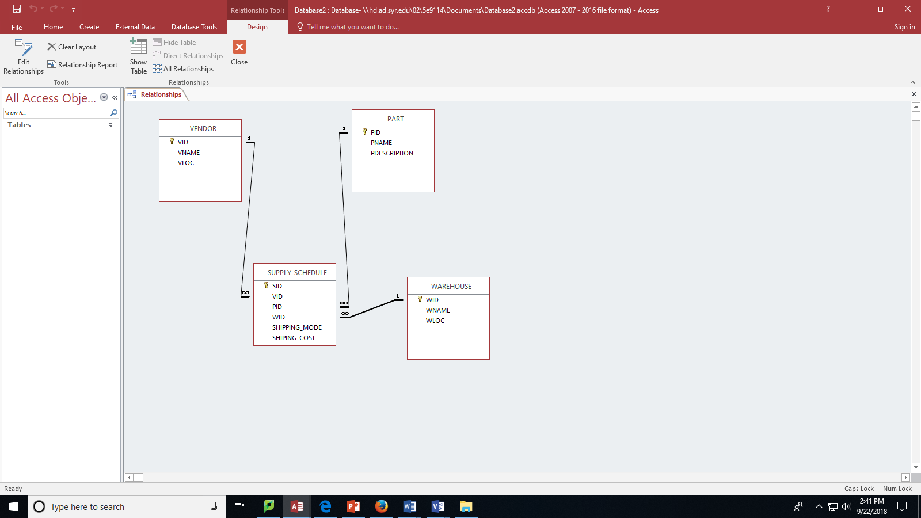

**Tables:**

SUPPLY-SCHEDULE:

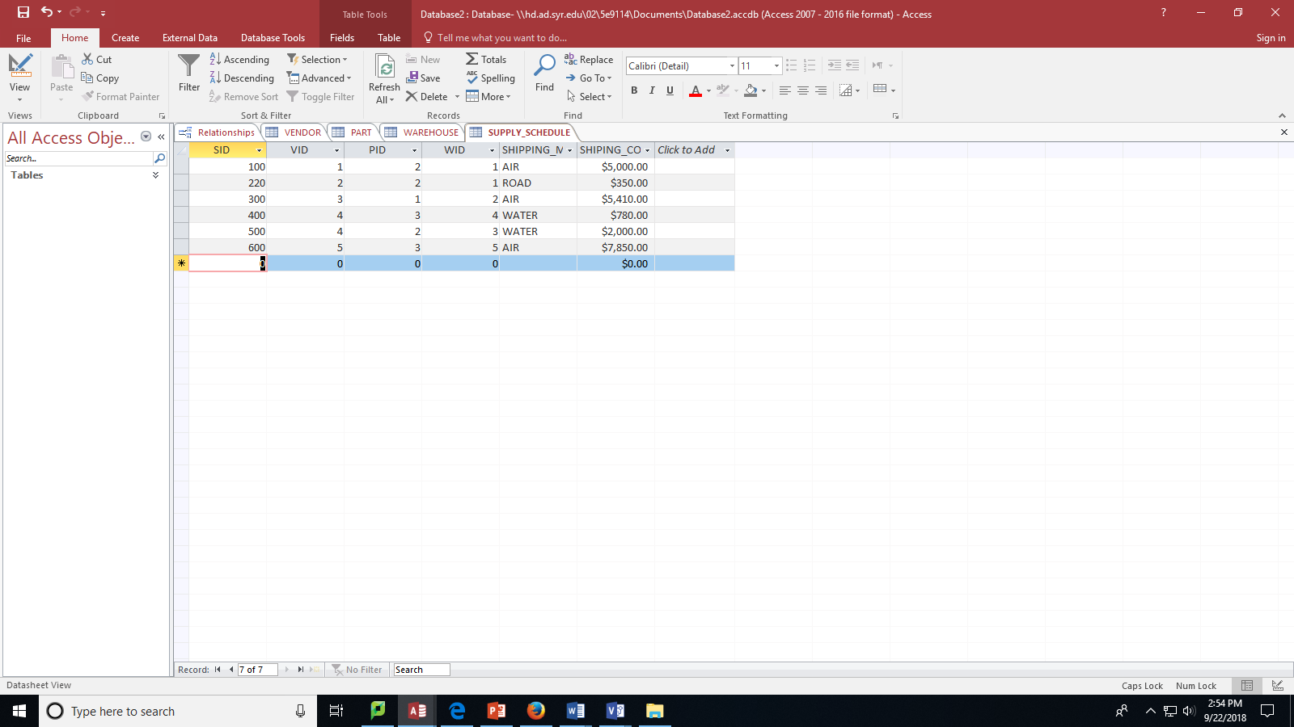

WAREHOUSE:

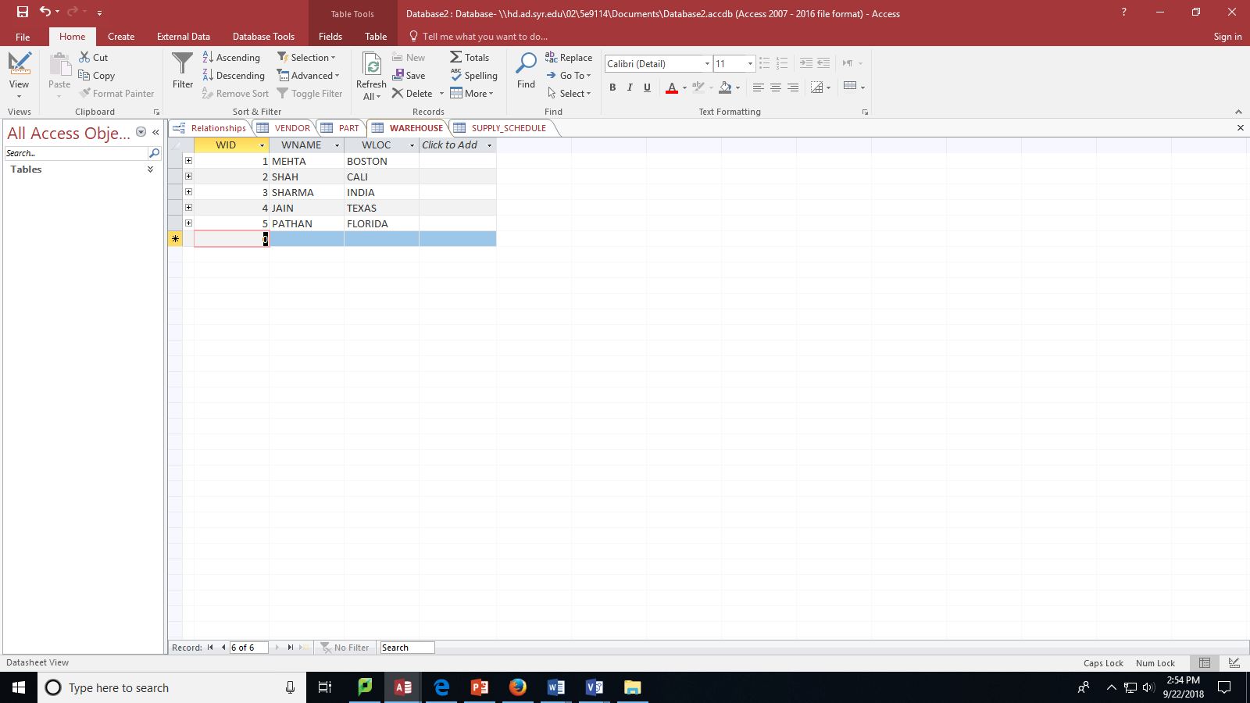

PART:

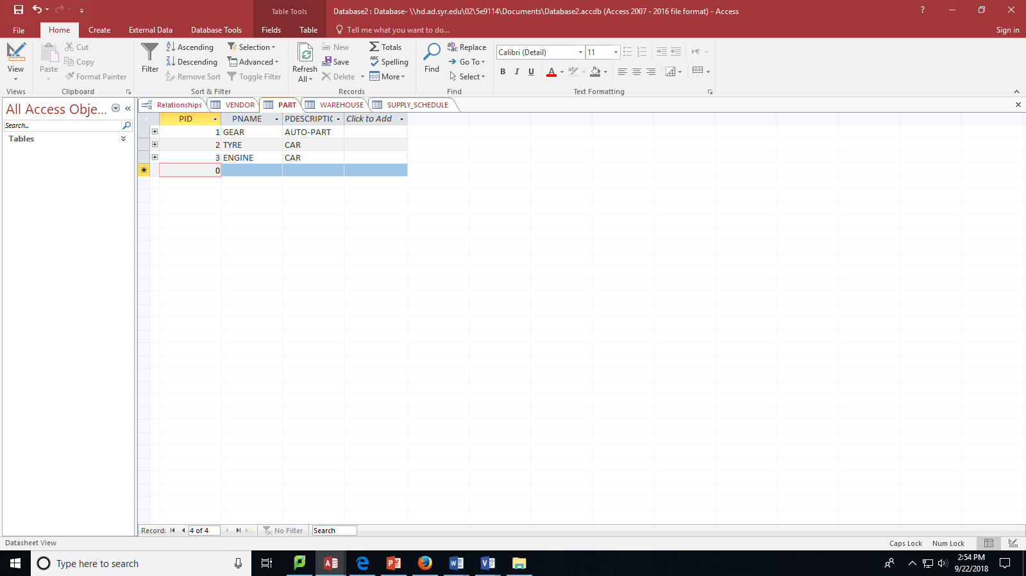

VENDOR:

